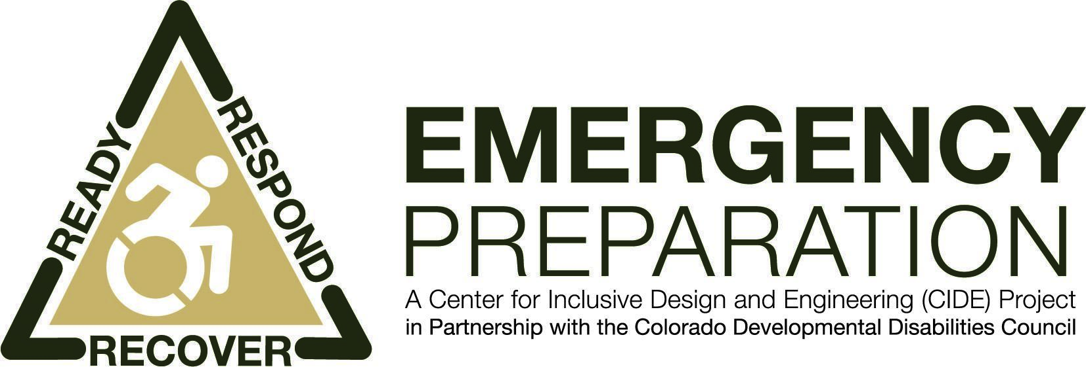

Disability Specific Emergency Kits for
Persons with Disabilities

Being ready for an emergency regardless of your location is imperative for survival and each location requires a different kit.*
- Personal Kit – contains essential items to keep with you at all times.
- Grab-and-Go/Workplace Kit – easy-to-carry kit to grab if you have to evacuate your location in a hurry. Contains items you can’t do without and are small enough and light enough you can carry.
- Home Kit – a large kit that contains essential supplies (water, food, first aid, clothing, bedding, tools, and items specific to your disability. It includes everything you need to be self-sufficient for 72 hours in your home or emergency shelter.
- Bedside Kit – contains items you need if you are trapped in or near your bed and unable to get to other parts of your home.
- Car Kit – includes items you need if you have to vacate the area in and around your vehicle during an evacuation.
- Service Animal Kit - includes familiar items to keep your service animal comfortable and secure in a time of stress

Contents of each kit needs to be tailored to your individual requirements and abilities. Ideally, you should plan for enough supplies, particularly medical supplies, to last up to two weeks. It is important to know ahead of time what you are realistically able to carry in a backpack or other small pack on your person or wheelchair, scooter, or other assistive device.
The following checklists contain suggestions for disability specific items to consider including in your various kits.
Breathing/Respiratory Limitations
- Alternate charging source
- Alternate power source
- Extra batteries, alternate power source, or charging system for oxygen and breathing devices
- N95 rated particulate filter mask
- Rechargeable batteries
- Resuscitation bag
- Towels, masks, industrial respirators or other supplies you can use to filter your air supply

Chemical/Food Sensitivities
- Alternate cooking method
- Antihistamine
- Disposable hand wipes
- Disposable plates and utensils
- Epinephrine auto-injector
- Ready-to-eat foods
- Special dietary supplements

Cognitive Limitations
- Organizational aids
  - Color Post-it flags
  - Color Sticky Notes
  - Highlighter markers
  - Highlighter tape
  - Memory Book
  - Notebook
- Prompting Devices
  - Picture prompting books
  - Talking Photo Album
  - Voice Cue

Communication or Speech Limitations
- Dry erase board
- Laminated alphabet boards
- Laminated communication board
- Low tech communication device

Hearing Limitations
- Alternate power source or charging system
- Amplification systems – pocket talker
- Cell phone amplifier
- Consider getting a weather radio with a visual/text display that warns of weather emergencies
- Dry erase board
- Extra cochlear implant batteries
- Extra hearing aid batteries
- Portable phone amplifier
- Vibrating watch

Mobility Limitations
- Bottle openers
- Cooling aids
- Dressing aids
- Drink holders
- Drinking aids – long straw, uDrink
- Eating aids
- Reachers
- Writing aids

Vision Limitations
- Big Print Address Book
- Booklight
- Cell phone magnifier
- Extra batteries, alternate power source or charging system
- Extra glasses
- Have high-powered flashlights with wide beams and extra batteries
- Liquid Level Indicator
- Magnifiers
- Mark your disaster supplies with fluorescent tape, large print or Braille
- Signature guide
- Talking watch
- Talking clock/calendar

Wheelchair or Scooter Users
- Battery charger
- Extra batteries, alternate power source or charging system
- Keep a lightweight manual wheelchair as a backup if possible
- Patch kit or can of sealant to repair flat tires and /or extra supply of inner tubes for non-puncture-proof wheelchair/scooter tires
- Tire repair kit

Medical Needs
- Blood pressure monitor
- Medi-straw
- Medication reminders/alarms
- Nail Clippers
- Pill boxes
- Pill splitter
- Pill popper
- Pill swallowing cup
- RX Magnifiers
- Talking Glucose Meter
- Thermometers
- USB MediTag

Service Animals/Pets
- Bedding/yoga mat
- Blankets or towels
- Can opener and disposable utensils
- Collar/ID/Leash/Safety Harness
- First Aid Kit
- Food & Water bowls
- Hygiene items (brush, shampoo, toothbrush)
- License/tags
- Medications
- Medical/vaccination records
- Pedigree papers
- Pet carrier with ID tag (include emergency contact numbers)
- Photo of animal, including distinguishing marks
- Sanitary Supplies (cat litter, old newspapers, trash bags, pooper scooper)
- Supply of pet food and treats (foods they are accustomed to eating to reduce digestive problems)
- Toys
- Water

* Please see ‘Emergency Kits for Persons with Disabilities or Access and Functional Needs’ for a suggested list of general items to include in your different kits.

For more information contact:

Center for Inclusive Design and Engineering
1201 5th St, Suite 240
Denver, CO 80204
303.315.1280 office
generalinfo@at-partners.org
HYPERLINK "http://www.assistivetechnologypartners.org" www1.ucdenver.edu/centers/cide

This publication may be reproduced without the written permission of Center for Inclusive
Design and Engineering provided that the source is appropriately credited.
Also available in: Braille, large print, audio tape, disk and Spanish formats
Made possible by NIDRR Grant #H224A40014

© 2021 The Regents of the University of Colorado, a body corporate. All rights reserved. Created by the Center for Inclusive Design and Engineering

For more information contact:

Center for Inclusive Design and Engineering
1201 5th St, Suite 240
Denver, CO 80204
303.315.1280 office
generalinfo@at-partners.org
HYPERLINK "http://www.assistivetechnologypartners.org" www1.ucdenver.edu/centers/cide

This publication may be reproduced without the written permission of Center for Inclusive
Design and Engineering provided that the source is appropriately credited.
Also available in: Braille, large print, audio tape, disk and Spanish formats
Made possible by NIDRR Grant #H224A40014

© 2021 The Regents of the University of Colorado, a body corporate. All rights reserved. Created by the Center for Inclusive Design and Engineering

