[Insert site phone number]
[Insert site contact email]

[Note: Back of Card]

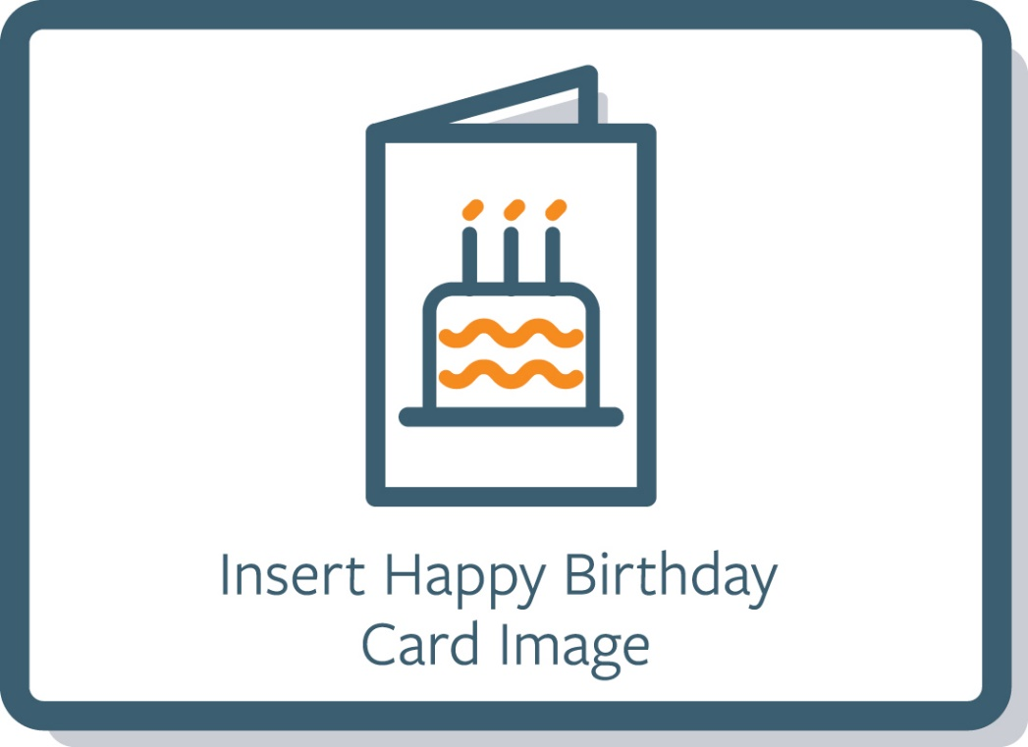

[Note: Front of Card]

Dear [Insert study participant’s name] or [Insert Study Name] Participant,

The [Insert study name] team would like to wish you a very Happy Birthday! We hope you have a wonderful birthday and a year filled with happiness.

We greatly value your continued commitment to advancing [insert research area] research and look forward to seeing you at your next study visit [optional: on Month DD, YYYY]!

Warm regards,
[Site Investigator and Coordinator Name]
Or
The [Insert Study Name] Team

[Note: Inside Flap]

