study Wallet CARD TEMPLATe

Use this document to create wallet cards for participants in an experimental drug trial to carry on their person throughout their participation. In case of an emergency, medical providers will be aware that the individual may be taking an experimental drug.

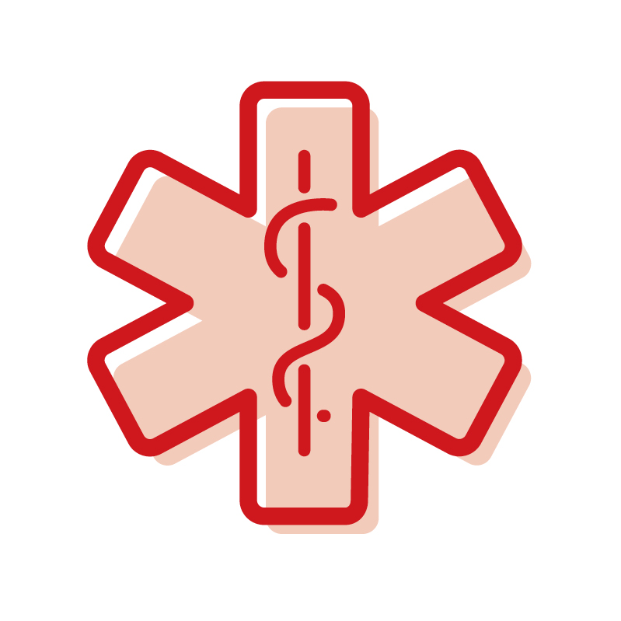  Study Participant Name  is participating in the [Insert Study Name] research study for [insert research area]and taking [Insert study drug] or placebo.  [Note: Side 1] | Medications to avoid:  - [List the medications that should not be taken while in the study.]  If you have any questions, please contact:  [Name]  [Phone]  [Email] [Note: Side 2]
Study Participant Name  is participating in the [Insert Study Name] research study for [insert research area] and taking [Insert study drug] or placebo.  [Note: Side 1] | Medications to avoid:  - [List the medications that should not be taken while in the study.]  If you have any questions, please contact:  [Name]  [Phone]  [Email] [Note: Side 2]
Study Participant Name  is participating in the [Insert Study Name] research study for [insert research area] and taking [Insert study drug] or placebo.  [Note: Side 1] | Medications to avoid:  - [List the medications that should not be taken while in the study.]  If you have any questions, please contact:  [Name]  [Phone]  [Email] [Note: Side 2]
Study Participant Name  is participating in the [Insert Study Name] research study for [insert research area]and taking [Insert study drug] or placebo.  [Note: Side 1] | Medications to avoid:  - [List the medications that should not be taken while in the study.]  If you have any questions, please contact:  [Name]  [Phone]  [Email] [Note: Side 2]

