How to Issue an Early Alert

- To access NAVIGATE, click on ucdenver.campus.eab.com or copy and paste this link in a new browser.
Login in with your ucdenver PassportID credentials.

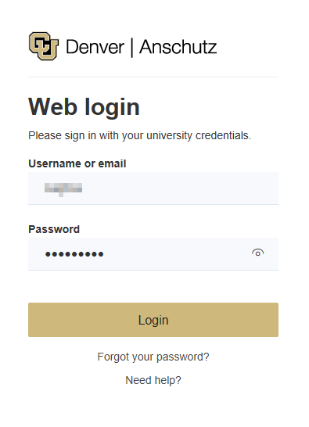

- This is how your NAVIGATE home screen will look
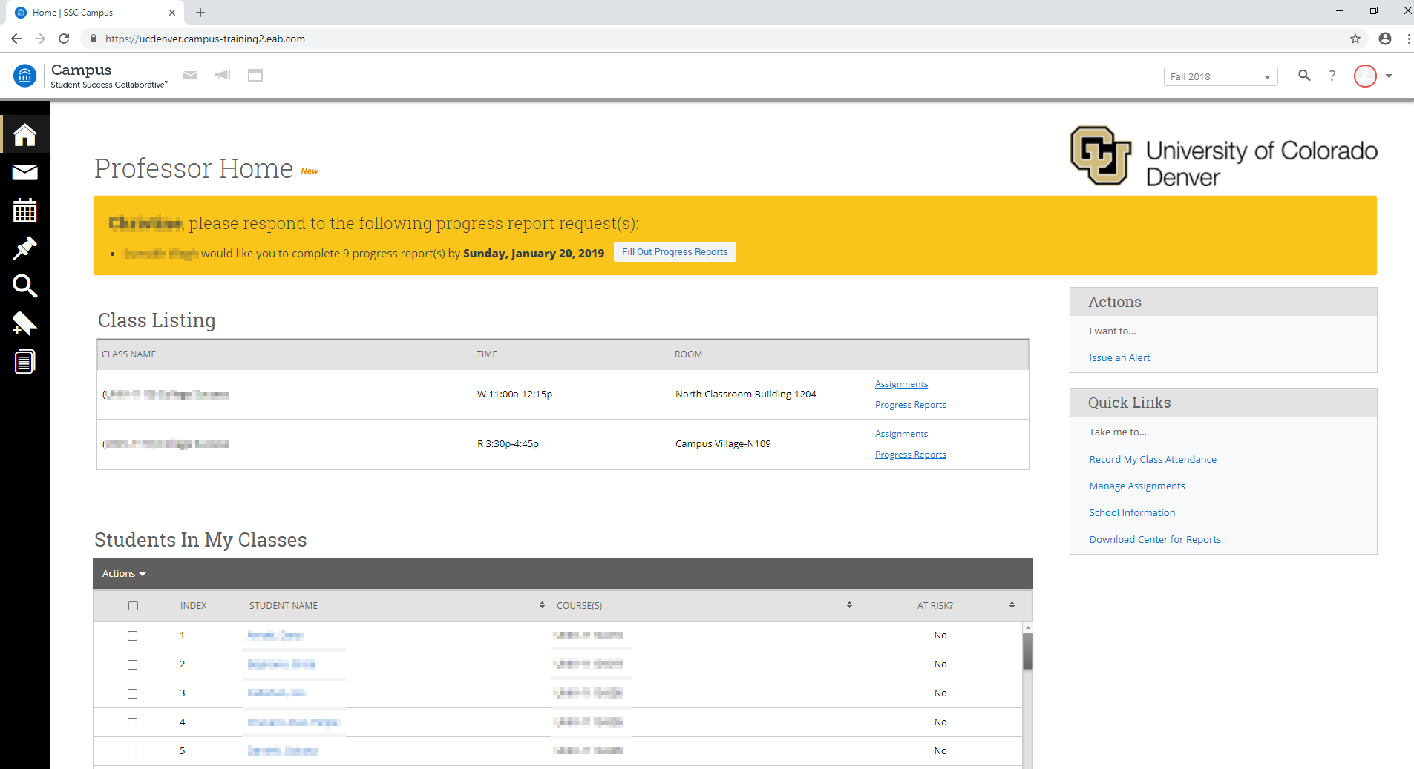

- Click on “Fill out Progress Reports”, which will appear on the yellow band on your home screen.
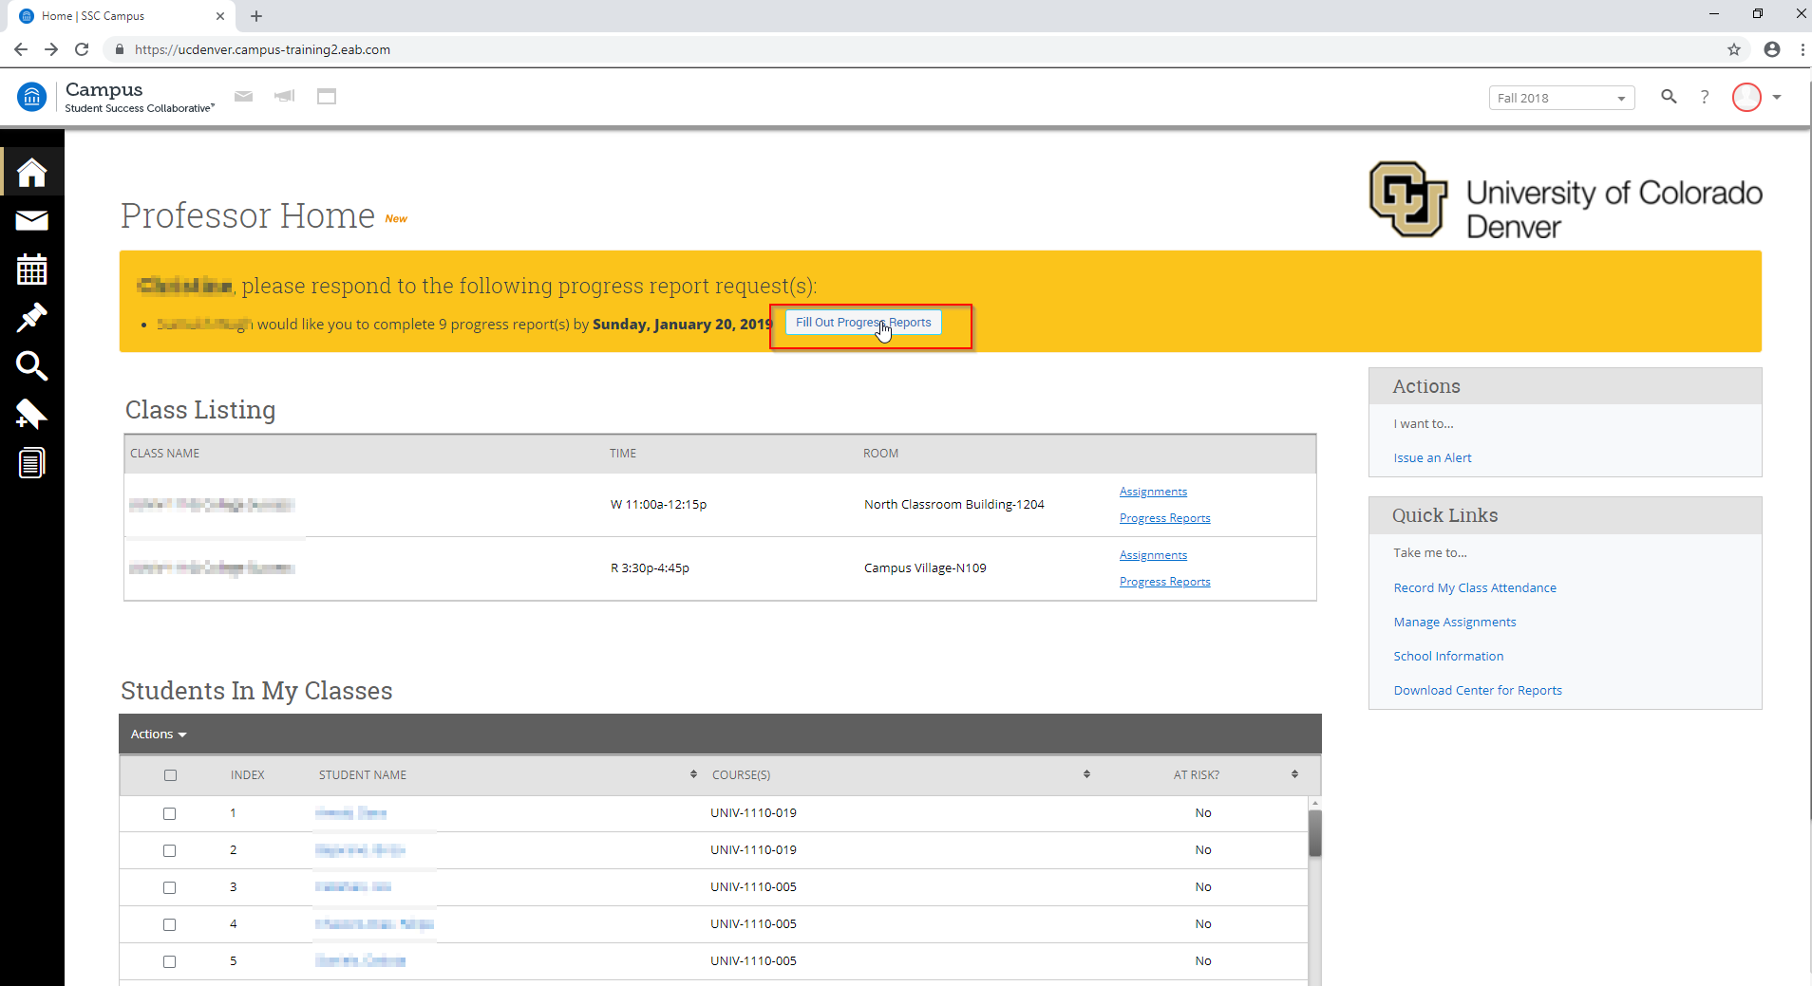
- Once you click on “Fill out Progress Reports”, you will be directed to this page. Select appropriate options for the students you want to create an alert on and then click on submit.

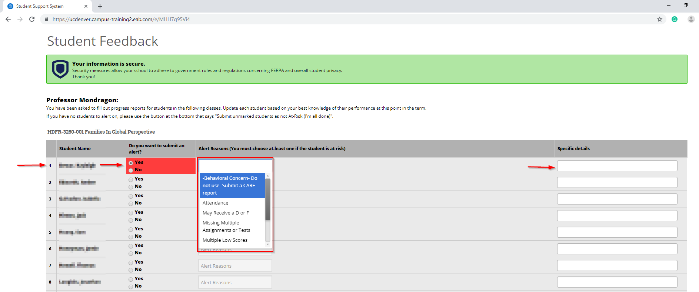

- After submitting, a case will be generated and it will be assigned to the respective advisor/contact.

Once you are done selecting the right options for students in the list, click any one option out the two given at the bottom of the page.
Be very careful while selecting the given option.

- Submit Only Marked Students (but I’m not done): Out of the listed students, select this option if you want to mark a few and submit the rest later.
- Submit unmarked students as not At-Risk (I’m all done): If out of 10 students you want to mark only 2 students who are at-risk of failing, you can select those 2 students and click this button. It will auto-select and submit the rest of your students as not at-risk.

If you do not have any students to alert on, click on the second option marked “Submit unmarked students as not At-Risk (I’m all done)”.
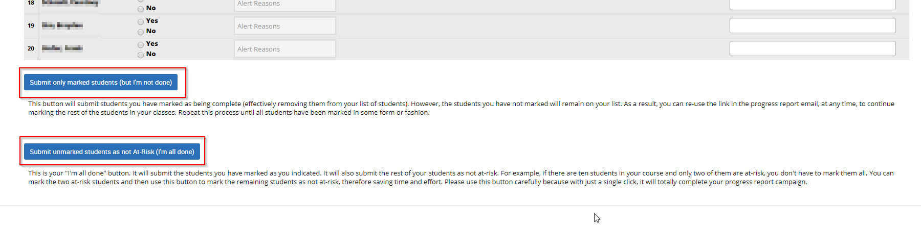

How to Issue a Progress Report

Throughout the Semester:

- This is how your Navigate home screen looks
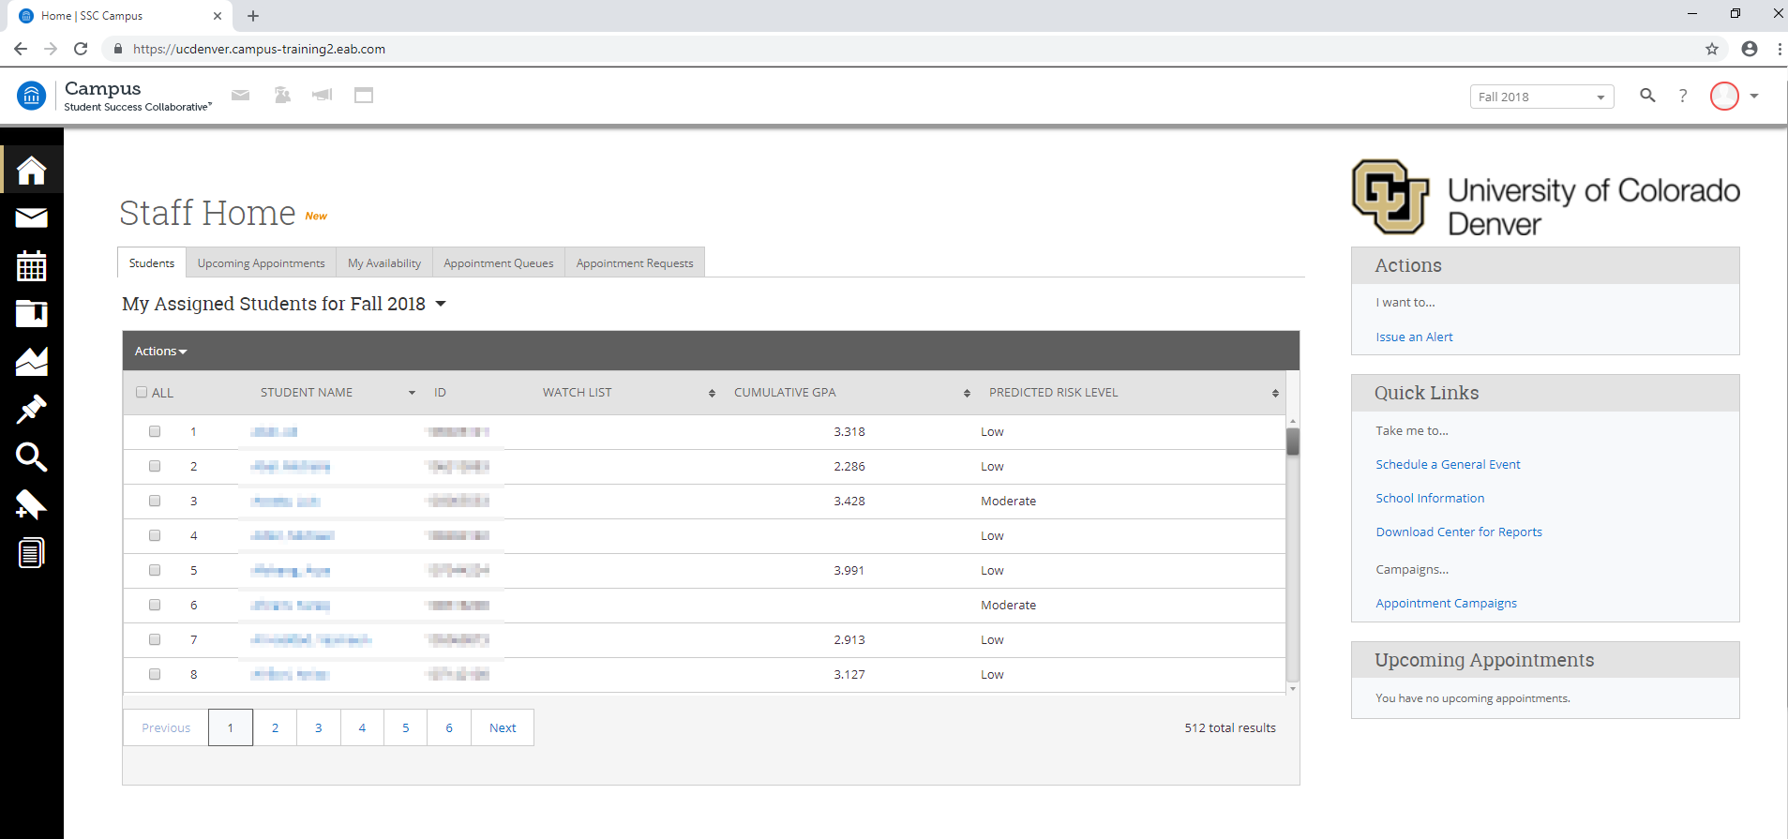

- Under “Students In My Classes”, select the box next to the student you wish to create a Progress Report on. On the drop-down list, select “Issue Alert”.
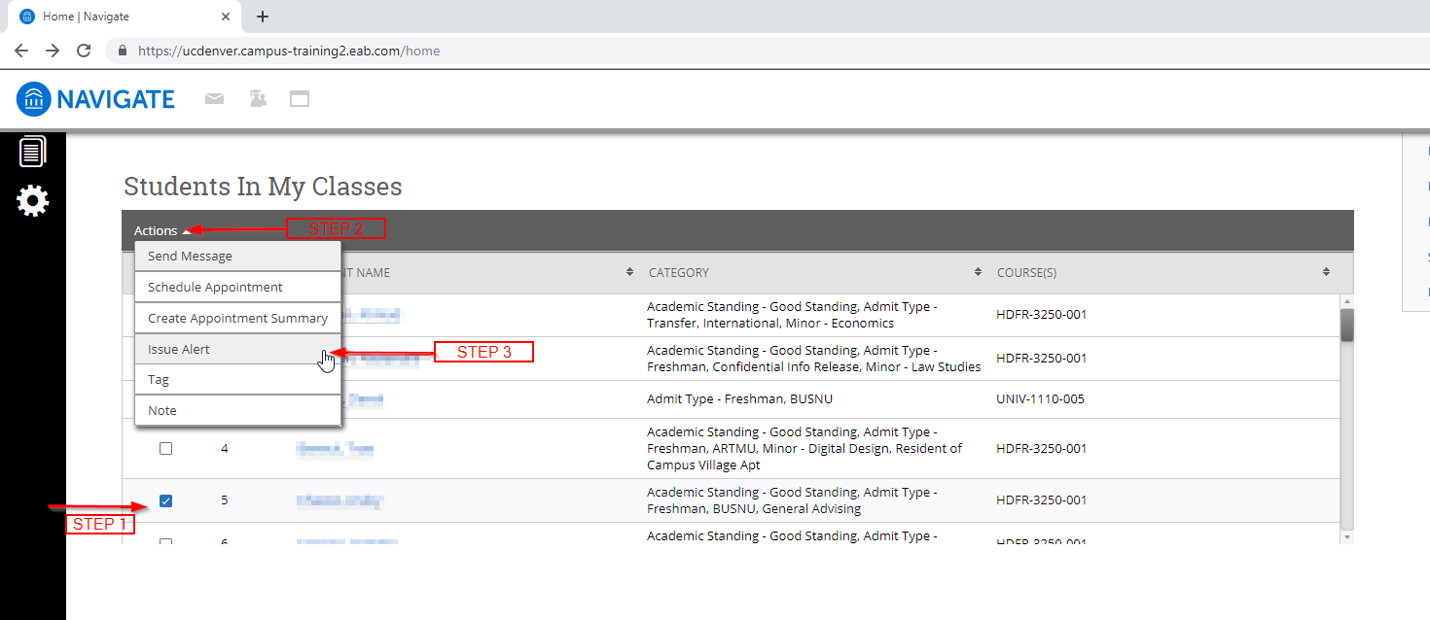

- Select the reason(s) for the alert. If the alert is associated with a specific course that you’re teaching, select that course. You can also add in additional comments that will be communicated to the contact for that alert.
